**“Experiment 1.2”**

Student Name: **SUMIT KUMAR** UID: **20BCS8226**

Branch: **CSE** Section/Group: **808 A**

Semester: **5th** Date of Submission: **05-09-22**

Subject Name: **Machine Learning Lab** Subject Code: **CSP-317**

1. **Aim:**

Implement Data Visualization.

1. **Software/Hardware Requirements:**

Windows 7 & above version

1. **Tools to be used:**

* Google Colab
* Python programming language

1. **Implementation:**

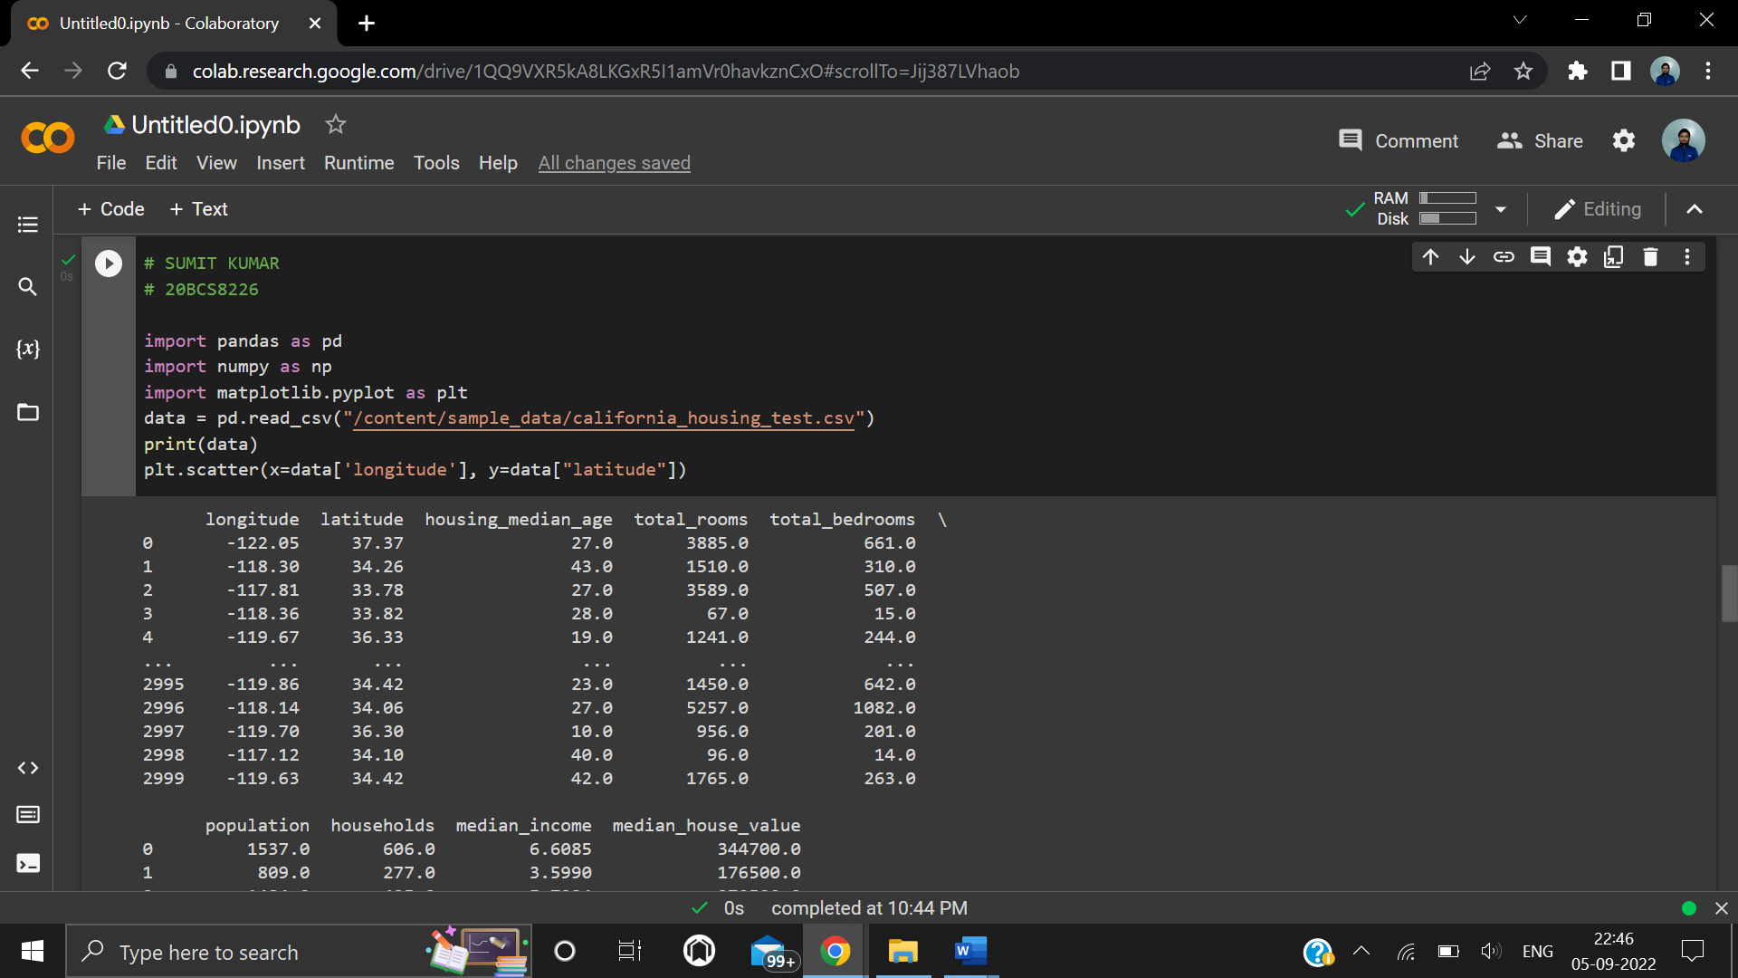

**Screenshot of my name, UID and unique dataset**

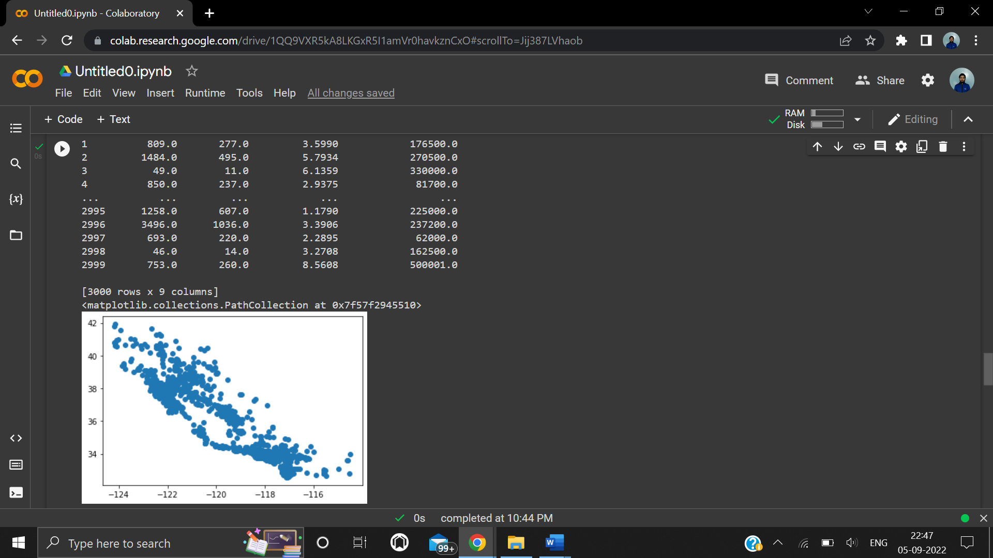

**Screenshot of Scatter Plot**

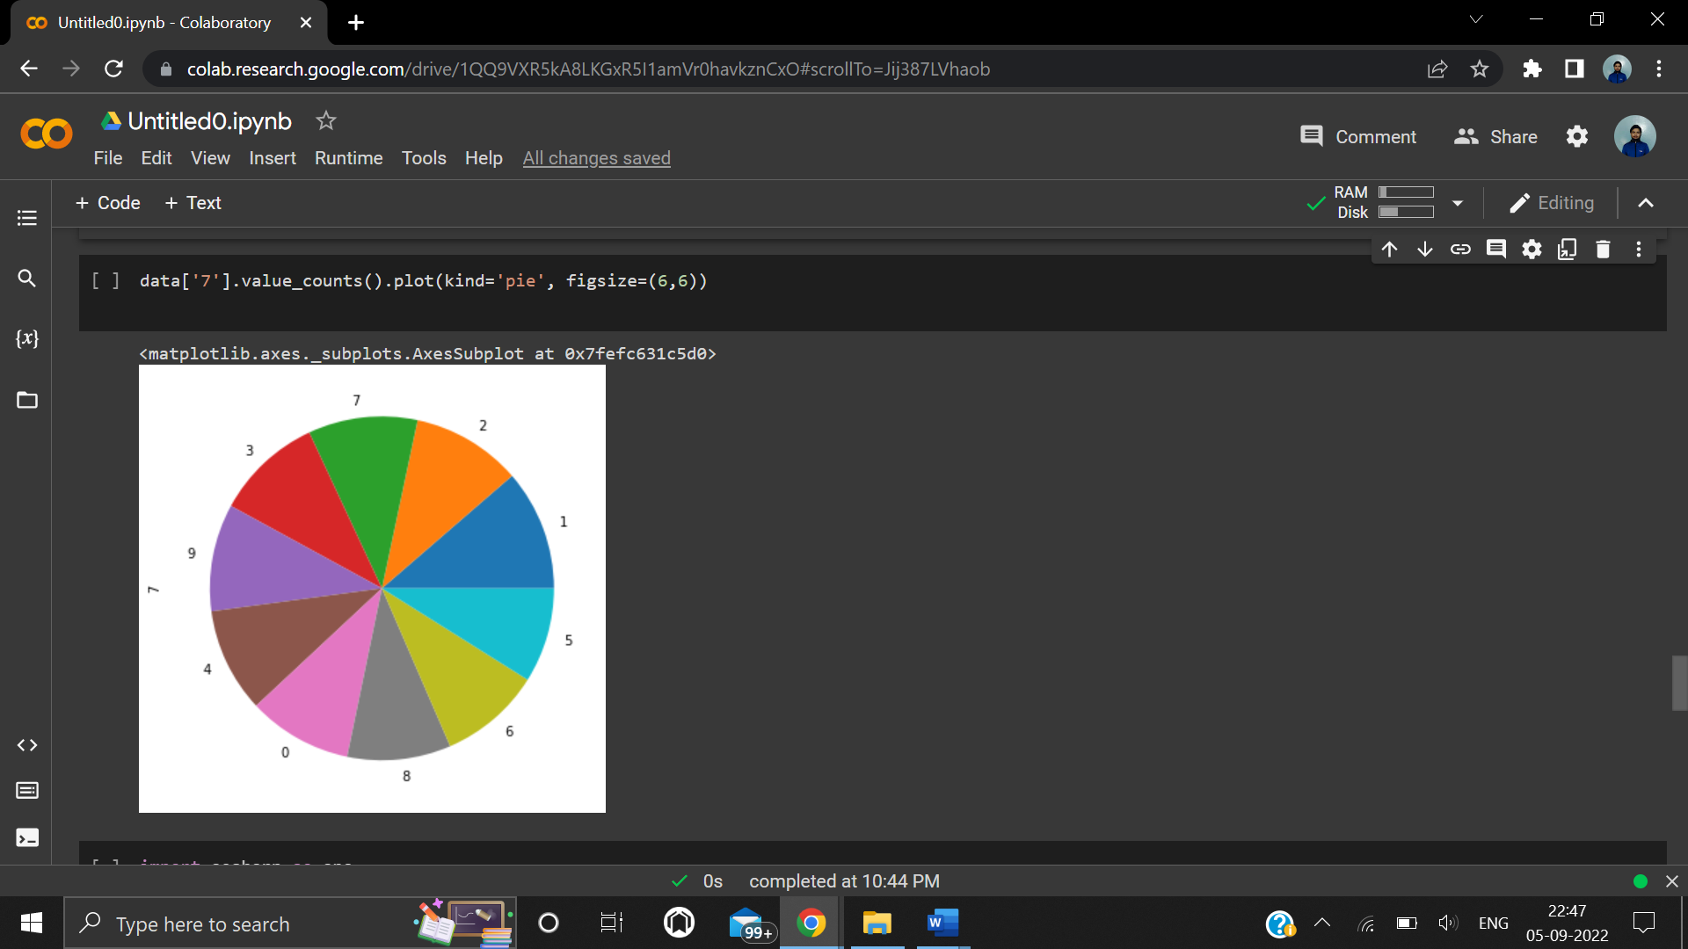

**Screenshot of Pie Plot**

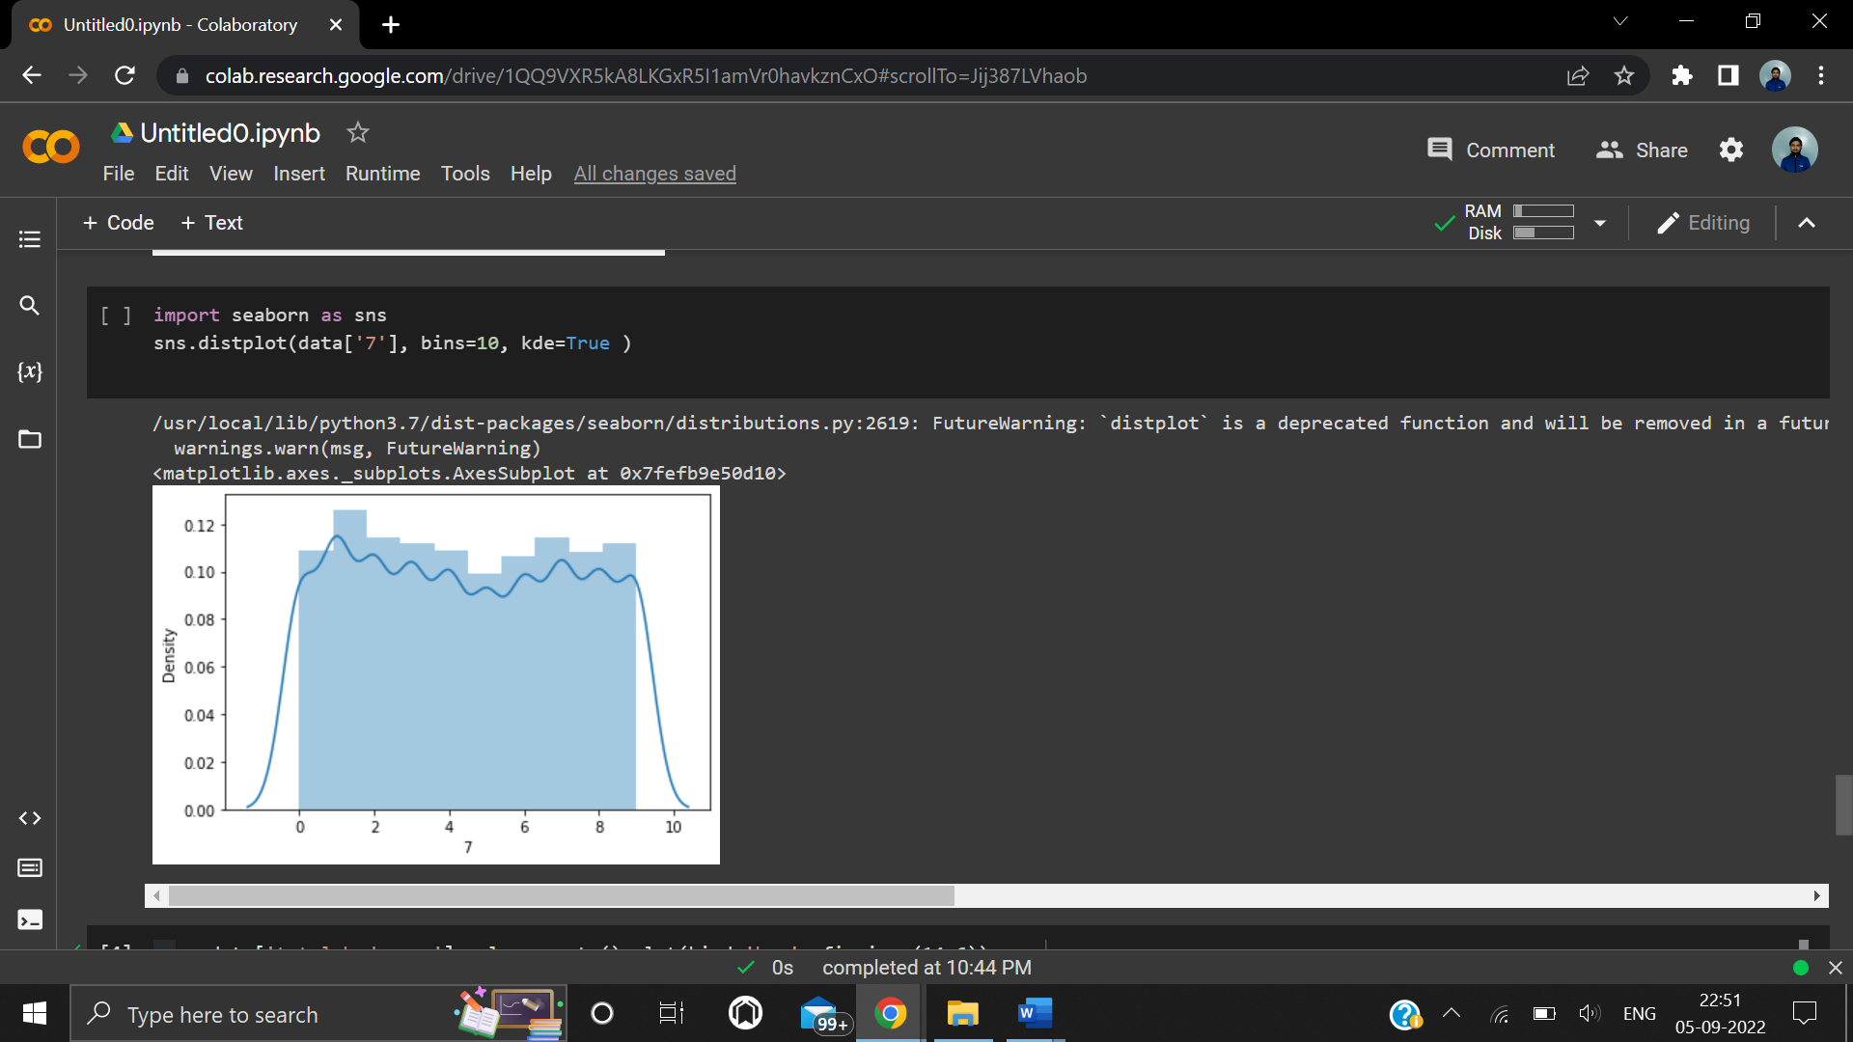

**Screenshot of Histogram**

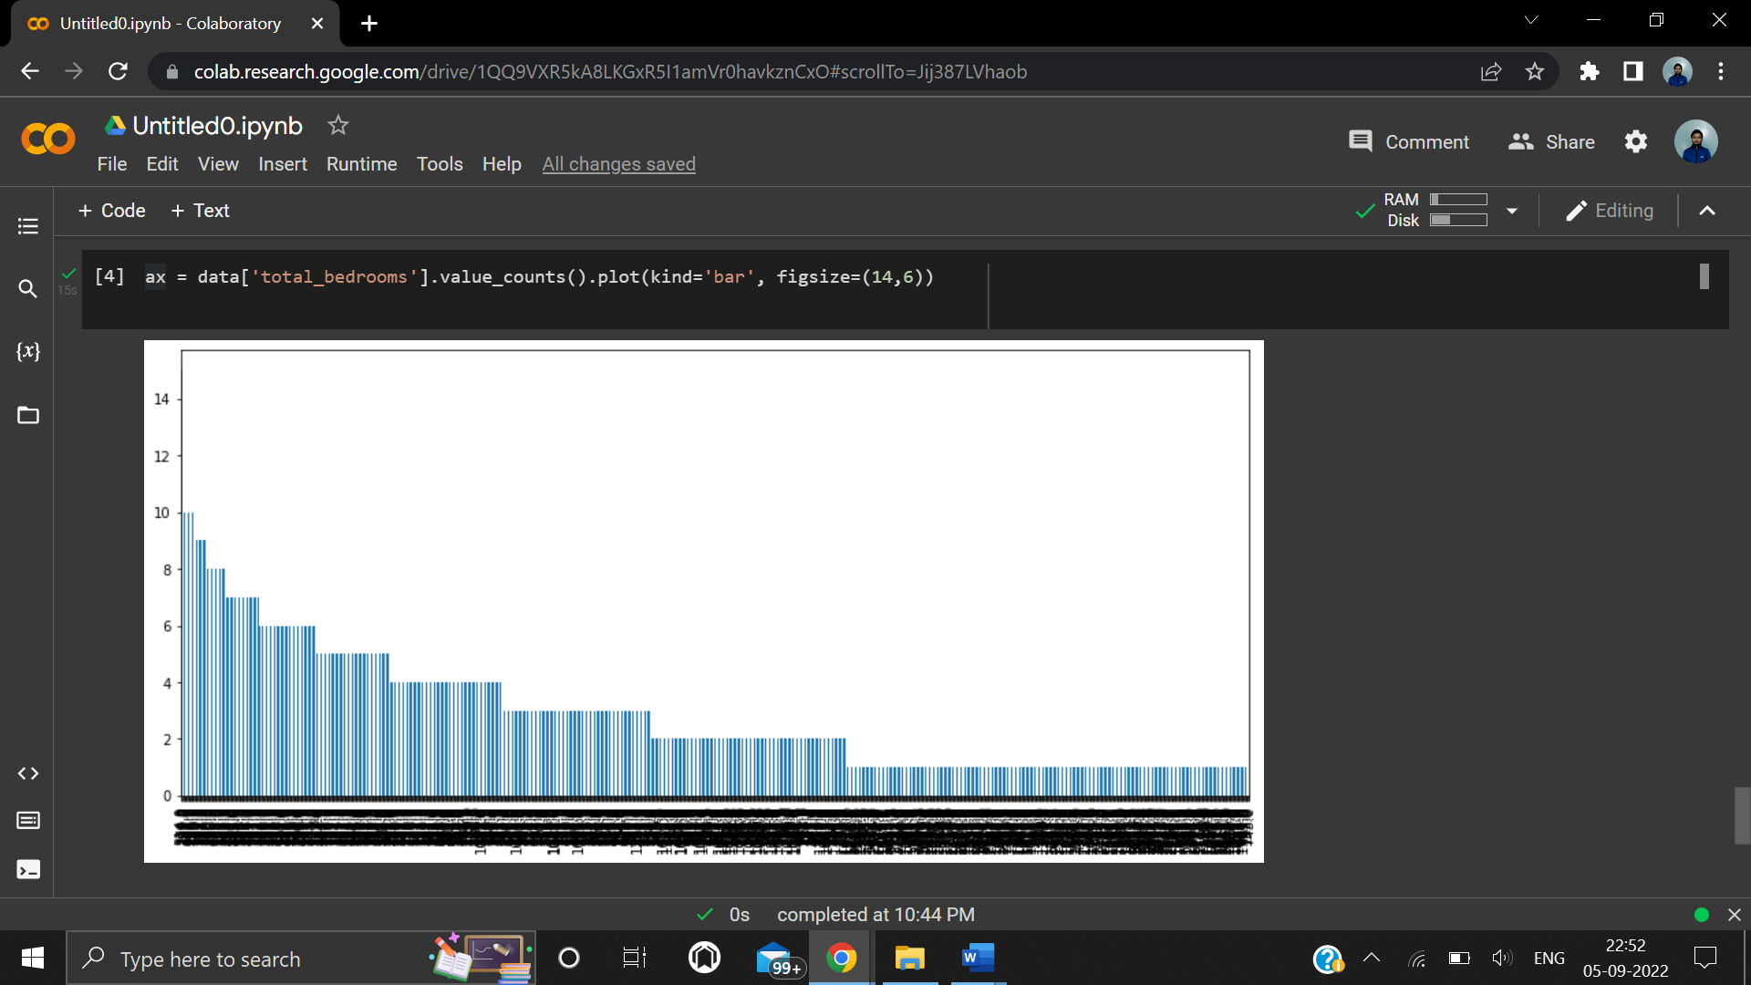

**Screenshot of Bar Plot**

**Learning outcomes (What I have learnt):**

1. To understand Data Visualization.

2. Learn about pandas’, matplotlib and seaborn library/package ofpython.

3. Learn about the different methods/functions that are needed to generate different types of graphs, charts and plots of the given dataset.

4. Leaned about regression line, KDE.

**Evaluation Grid:**

|  |  |  |  |
| --- | --- | --- | --- |
| **Sr. No.** | **Parameters** | **Marks Obtained** | **Maximum Marks** |
| **1.** |  |  |  |
| **2.** |  |  |  |
| **3.** |  |  |  |
|  |  |  |  |